**ATTENDANCE SYSTEM BASED ON FACE**

**RECOGNITION USING LBPH AND OPENCV**

**A PROJECT REPORT**

***Submitted by***

**SIDDHARTH K – 312320205154**

**VISHAL S – 312320205178**

**OF**

**BACHELOR OF TECHNOLOGY**

**INFORMATION TECHNOLOGY**



**St. JOSEPH’S COLLEGE OF ENGINEERING**

**(An Autonomous Institution)**

**St. Joseph’s Group of Institutions**

Jeppiaar Educational Trust

**OMR, Chennai 600 119**

**ANNA UNIVERSITY: CHENNAI**

**MARCH-2023**

**ANNA UNIVERSITY: CHENNAI 600 025**



**BONAFIDE CERTIFICATE**

Certified that this project report **“ATTENDANCE SYSTEM BASED ON FACE RECOGNITION USING LBPH AND OPENCV”** is the bonafide work of **SIDDHARTH K (312320205154)** and **VISHAL S (312320205178)** who carried out the project under my supervision.

SIGNATURE

Project Guide,

Mr. N. Raja Mohamed M.E.,

Assistant Professor, Department of IT,

St. Joseph’s College of Engineering, OMR, Chennai- 600119.

SIGNATURE

Head of the department-Lab Affairs,

Dr. V Muthulakshmi, M.E., Ph.D.,

Associate Professor, Department of IT,

St. Joseph’s College of Engineering, OMR, Chennai- 600119.

**CERTIFICATE OF EVALUATION**

**COLLEGE NAME :** St. Joseph’s College of Engineering, Chennai-600119.

**BRANCH :** B. Tech-IT(Information Technology)

**SEMESTER: :** VI

|  |  |  |  |
| --- | --- | --- | --- |
| **SL. NO** | **NAME OF THE STUDENT** | **TITLE OF THE PROJECT** | **NAME OF THE SUPERVISOR WITH DESIGNATION** |
| 1  2 | SIDDHARTH K  (312320205154)  VISHAL S (312320205178) | ATTENDANCE SYSTEM BASED ON FACE RECOGNITION USING LHPH AND OPENCV | Mr. N. Raja Mohamed M.E.,  ASSISTANT PROFESSOR |

The report of the project work submitted by the above students in partial fulfillment for the award of Bachelor of Technology Degree in Information Technology of Anna University was confirmed to be report of the work done by the above students and then evaluated.

Submitted to Project and Viva Examination held on .

**INTERNAL EXAMINER EXTERNAL EXAMINER**

ACKNOWLEDGEMENT

At the outset we would like to express our sincere gratitude to the beloved **Chairman, Dr.Babu Manoharan, M.A.,M.B.A.,Ph.D.,** for his constant guidance and support.

We would like to express our heartfelt thanks to our respected **Managing Director Mrs. S. Jessie Priya, M.Com.,** for her kind encouragement and blessings.

We wish to express our sincere thanks to our **Executive Director Mr. B. Shashi Sekar, M.Sc.,** for providing ample facilities in the institution.

We express our deepest gratitude and thanks to our beloved **Principal Dr.Vaddi Seshagiri Rao, M.E., M.B.A., Ph.D., F.I.E.,** for his inspirational ideas during the course of the project.

We wish to express our sincere thanks and gratitude to **Dr.V. Muthulakshmi, M.E.,Ph.D.,** Professor,Head of the department-Lab Affairs, Department of Information Technology, St. Joseph’s College of Engineering for her guidance and assistance in solving the various intricacies involved in the project.

It is with deep sense of gratitude that we acknowledge our indebtness to our supervisor **Mr. Raja Mohamed N, M.E.,** for his expert guidance and connoisseur suggestion.

Finally we thank our department staff members who helped us in the successful completion of this project.

**TABLE OF CONTENTS**

**CHAPTER TITLE PAGE NO NO**

**ABSTRACT**

|  |  |
| --- | --- |
| **LIST OF FIGURES LIST OF TABLES**  **CHAPTER 1 INTRODUCTION** |  |
| 1.1 Project Objective | 2 |
| 1.2 Background | 3,4 |
| 1.3 Problem Statement | 5 |
| 1.4 Aims and Objectivee | 6 |
| 1.5 Flow chart | 7 |
| \1.6 Scope of the project | 8 |
| **CHAPTER 2 LITERATURE REVIEW** |  |
| 2.1 Student Attendance System | 10 |
| 2.2 Digital Image Processing | 11 |
| 2.3 Image Representation in a Digital Computer | 11 |
| 2.4 Steps in Digital Image Processing | 11 |
| 2.5 Definiton of Terms and History | 12 |
| 2.5.1 Face Detection | 13 |
| 2.5.2 Local Binary Pattern Histogram | 16 |
| **CHAPTER 3 MODAL IMPLEMENTATION AND ANALYSIS** |  |
| 3.1 Introduction | 22 |
| 3.2 Modal Implementation | 22 |
| 3.3 Design Requirements | 23 |

**1**

**2**

**3**

* + 1. Software Implementation 23

3.4 Experimental Results 25

**4 CHAPTER 4 CODE IMPLEMENTATION**

* 1. Code Implementation 29

4.1.1 attendance.py 30

* + 1. automaticattendance.py 32
    2. takeimage,py 34
    3. trainimage.py 35
    4. showattendance.py 36
    5. requirement.txt 36
  1. Sample Images 37

**5 CHAPTER 5 WORKPLAN**

* 1. Introduction 40
  2. Work Breakdown Structure 40
     1. Financial Plan 42

**6** **CHAPTER 6 PERFORMANCE ANALYSIS**

* 1. Introduction 44
  2. Analysis 44
  3. Flowchart 45

**7 CONCLUSION** 46

**8 REFERENCES** 47

**LIST OF FIGURES**

**Figure no Topic Page**

1.1 Project outline 7

2.1 A diagram showing the steps in digital image processing 12

2.2 Haar Feature 15

2.3 Integral of Image 15

2.4 LBP Operation 17

2.5 The LBP operation Radius charge 18

2.6 Extracting the Histogram 19

3.1 Model Implement 22

3.2 Installing OpenCV 24

4.1 Output Image 38

**LIST OF TABLES**

**TABLE NO TOPIC PAGE**

2.1 Advantages and Disadvantages of 10

Difference Biometric System

2.2 Advantages and Disadvantages of Face 14

Detection Method

3.2 Experimental Results 26

3.3 Experimental Results-2 27

5.1 Work plan 41

5.2 Financial Plan 42

**ABSTRACT**

In colleges, universities, organizations, schools, and offices, taking attendance is one of the most important tasks that must be done on a daily basis. The majority of the time, it is done manually, such as by calling by name or by roll number. The main goal of this project is to create a Face Recognition-based attendance system that will turn this manual process into an automated one. This project meets the requirements for bringing modernization to the way attendance is handled, as well as the criteria for time management. This device is installed in the classroom, where and student's information, such as name, roll number, and photographs, is trained. The images are extracted using Open CV. Before the start of the corresponding class, the student can approach the machine, which will begin taking pictures and comparing them to the qualified dataset. The project is implemented in the surveillance camera installed in the classroom. The image is processed as follows: first, faces are identified using a Haarcascade classifier, then faces are recognized using the LBPH (Local Binary Pattern Histogram) Algorithm, histogram data is checked against an established dataset, and the device automatically labels attendance. An Excel sheet is developed, and it is updated every hour with the information from the respective class instructor.

**CHAPTER-1 INTRODUCTION**

* 1. **Project Objective:**

Attendance is prime important for both the teacher and student of an educational organization. So it is very important to keep record of the attendance. The problem arises when we think about the traditional process of taking attendance in class room.

Calling name or roll number of the student for attendance is not only a problem of time consumption but also it needs energy. So an automatic attendance system can solve all above problems.

There are some automatic attendances making system which are currently used by much institution. One of such system is biometric technique. Although it is automatic and a step ahead of traditional method it fails to meet the time constraint. The student has to wait in queue for giving attendance, which is time taking.

This project introduces an involuntary attendance marking system, devoid of any kind of interference with the normal teaching procedure. The system can be also implemented during exam sessions or in other teaching activities where attendance is highly essential. This system eliminates classical student identification such as calling name of the student, or checking respective identification cards of the student, which can not only interfere with the ongoing teaching process, but also can be stressful for students during examination sessions. In addition, the students have to register in the database to be recognized. The enrolment can be done on the spot through the user- friendly interface.

* 1. **Background:**

Face recognition is crucial in daily life in order to identify family, friends or someone we are familiar with. We might not perceive that several steps have actually taken in order to identify human faces. Human intelligence allows us to receive information and interpret the information in the recognition process. We receive information through the image projected into our eyes, by specifically retina in the form of light. Light is a form of electromagnetic waves which are radiated from a source onto an object and projected to human vision. Robinson-Riegler, G., & Robinson-Riegler, B. (2008) mentioned that after visual processing done by the human visual system, we actually classify shape, size, contour and the texture of the object in order to analyze the information. The analyzed information will be compared to other representations of objects or face that exist in our memory to recognize. In fact, it is a hard challenge to build an automated system to have the same capability as a human to recognize faces. However, we need large memory to recognize different faces, for example, in the Universities, there are a lot of students with different race and gender, it is impossible to remember every face of the individual without making mistakes. In order to overcome human limitations, computers with almost limitless memory, high processing speed and power are used in face recognition systems.

The human face is a unique representation of individual identity. Thus, face recognition is defined as a biometric method in which identification of an individual is performed by comparing real-time capture image with stored images in the database.

Nowadays, face recognition system is prevalent due to its simplicity and awesome performance. For instance, airport protection systems and FBI use face recognition for criminal investigations by tracking suspects, missing children and drug activities. Apart from that, Facebook which is a popular social networking website implement face recognition to allow the users to tag their friends in the photo for entertainment purposes. Furthermore, Intel Company allows the users to use face recognition to get access to their online account. Apple allows the users to unlock their mobile phone, iPhone X by using face recognition.

The work on face recognition began in 1960. Woody Bledsoe, Helen Chan Wolf and Charles Bisson had introduced a system which required the administrator to locate eyes, ears, nose and mouth from images. The distance and ratios between the located features and the common reference points are then calculated and compared. The studies are further enhanced by Goldstein, Harmon, and Lesk in 1970 by using other features such as hair colour and lip thickness to automate the recognition. In 1988, Kirby and Sirovich first suggested principle component analysis (PCA) to solve face recognition problem. Many studies on face recognition were then conducted continuously until today.

* 1. **Problem Statement:**

Traditional student attendance marking technique is often facing a lot of trouble. The face recognition student attendance system emphasizes its simplicity by eliminating classical student attendance marking technique such

calling student names or checking respective identification cards. There are not only disturbing the teaching process but also causes distraction for students during exam sessions. Apart from calling names, attendance sheet is passed around the classroom during the lecture sessions. The lecture class especially the class with a large number of students might find it difficult to have the attendance sheet being passed around the class. Thus, face recognition attendance system is proposed in order to replace the manual signing of the presence of students which are burdensome and causes students get distracted in order to sign for their attendance. Furthermore, the face recognition based automated student attendance system able to overcome the problem of fraudulent approach and lecturers does not have to count the number of students several times to ensure the presence of the students.

The paper proposed by Zhao, W et al. (2003) has listed the difficulties of facial identification. One of the difficulties of facial identification is the identification between known and unknown images. In addition, paper proposed by Pooja G.R et al. (2010) found out that the training process for face recognition student attendance system is slow and time-consuming. In addition, the paper proposed by Priyanka Wagh et al. (2015) mentioned that different lighting and head poses are often the problems that could degrade the performance of face recognition based student attendance system.

Hence, there is a need to develop a real time operating student attendance system which means the identification process must be done within defined time constraints to prevent omission. The extracted features from facial images which represent the identity of the students have to be consistent towards a change in background, illumination, pose and expression. High accuracy and fast computation time will be the evaluation points of the performance.

* 1. **Aims and Objectives:**

The objective of this project is to develop attendance system based on face recognition .

Expected achievements in order to fulfill the objectives are:

* + - To detect the face segment from the video frame.
    - To extract the useful features from the face detected.
    - To classify the features in order to recognize the face detected.
    - To record the attendance of the identified student.
  1. **Flow chart**

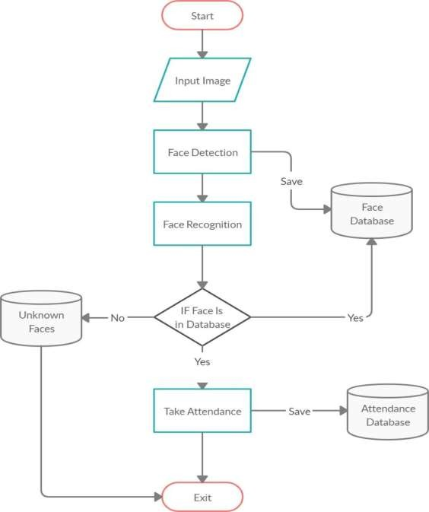

1.1 Project Outline

* 1. **Scope of the project:**

We are setting up to design a system comprising of two modules. The first module (face detector) is a mobile component, which is basically a camera application that captures student faces and stores them in a file using computer vision face detection algorithms and face extraction techniques. The second module is a desktop application that does face recognition of the captured images (faces) in the file, marks the students register and then stores the results in a database for future analysis.

**CHAPTER-2 LITERATURE REVIEW**

* 1. **Student Attendance System:**

Arun Katara et al. (2017) mentioned disadvantages of RFID (Radio Frequency Identification) card system, fingerprint system and iris recognition system. RFID card system is implemented due to its simplicity. However, the user tends to help their friends to check in as long as they have their friend’s ID card. The fingerprint system is indeed effective but not efficient because it takes time for the verification process so the user has to line up and perform the verification one by one. However for face recognition, the human face is always exposed and contain less information compared to iris. Iris recognition system which contains more detail might invade the privacy of the user. Voice recognition is available, but it is less accurate compared to other methods. Hence, face recognition system is suggested to be implemented in the student attendance system.

|  |  |  |
| --- | --- | --- |
| **System Type** | **Advantage** | **Disadvantages** |
| RFID card system | Simple | Fraudulent usage |
| Fingerprint system | Accurate | Time-consuming |
| Voice recognition system |  | Less accurate compared to Others |
| Iris recognition system | Accurate | Privacy Invasion |

Table 2.1: Advantages & Disadvantages of Different Biometric System

* 1. **Digital Image Processing:**

Digital Image Processing is the processing of images which are digital in nature by a digital computer. Digital image processing techniques are motivated by three major applications mainly:

* + - Improvement of pictorial information for human perception
    - Image processing for autonomous machine application
    - Efficient storage and transmission.
  1. **Image Representation in a Digital Computer:**

An image is a 2-Dimensional light intensity function

𝐟 (𝐱,𝐲) = 𝐫 (𝐱,𝐲) × 𝐢 (𝐱,𝐲) -(2.0)

Where, r (x, y) is the reflectivity of the surface of the corresponding image point. i (x,y) Represents the intensity of the incident light. A digital image f(x, y) is discretized both in spatial co-ordinates by grids and in brightness by quantization. Effectively, the image can be represented as a matrix whose row, column indices specify a point in the image and the element value identifies gray level value at that point. These elements are referred to as pixels or pels.

Typically following image processing applications, the image size which is used is𝟐𝟓𝟔 × 𝟐𝟓𝟔, elements, 𝟔𝟒𝟎 × 𝟒𝟖𝟎 pels or 𝟏𝟎𝟐𝟒 × 𝟏𝟎𝟐𝟒 pixels. Quantization of these matrix pixels is done at 8 bits for black and white images and 24 bits for colored images (because of the three color planes Red, Green and Blue each at 8 bits)[.

* 1. **Steps in Digital Image Processing:**

Digital image processing involves the following basic tasks:

* + - Image Acquisition - An imaging sensor and the capability to digitize the signal produced by the sensor.
    - Preprocessing – Enhances the image quality, filtering, contrast enhancement etc.
    - Segmentation – Partitions an input image into constituent parts of objects.
    - Description/feature Selection – extracts the description of image objects suitable for further computer processing.
    - Recognition and Interpretation – Assigning a label to the object based on the information provided by its descriptor. Interpretation assigns meaning to a set of labelled objects.
    - 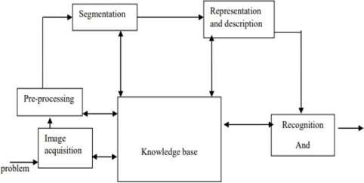Knowledge Base – This helps for efficient processing as well as inter module cooperation.

Figure 2.1 : A diagram showing the steps in digital image processing

* 1. **Definition of Terms and History:**

**Face Detection**

Face detection is the process of identifying and locating all the present faces in a single image or video regardless of their position, scale, orientation, age and expression. Furthermore, the detection should be irrespective of extraneous illumination conditions and the image and video content.

* + 1. **Face Recognition**

Face Recognition is a visual pattern recognition problem, where the face, represented as a three dimensional object that is subject to varying illumination,

pose and other factors, needs to be identified based on acquired images.

Face Recognition is therefore simply the task of identifying an already detected face as a known or unknown face and in more advanced cases telling exactly whose face it is.

**Difference between Face Detection and Face Recognition**

Face detection answers the question, Where is the face? It identifies an object as a “face” and locates it in the input image. Face Recognition on the other hand answers the question who is this? Or whose face is it? It decides if the detected face is someone .It can therefore be seen that face detections output (the detected face) is the input to the face recognizer and the face Recognition’s output is the final decision i.e. face known or face unknown.

**Face Detection**

A face Detector has to tell whether an image of arbitrary size contains a human face and if so, where it is. Face detection can be performed based on several cues: skin color (for faces in color images and videos, motion (for faces in videos), facial/head shape, facial appearance or a combination of these parameters. Most face detection algorithms are appearance based without using other cues. An input image is scanned at all possible locations and scales by a sub window. Face detection is posed as classifying the pattern in the sub window either as a face or a non-face. The face/nonface classifier is learned from face and non-face training examples using statistical learning methods. Most modern algorithms are based on the Viola Jones object detection framework, which is based on Haar Cascades.

|  |  |  |
| --- | --- | --- |
| **Face Detection**  **Method** | **Advantages** | **Disadvantages** |
| Viola Jones Algorithm | 1. High detection Speed. 2. High Accuracy. | 1. Long Training Time. 2.Limited Head Pose. 3.Not able to detect dark faces. |
| Local Binary Pattern Histogram | 1.Simple computation. 2.High tolerance against the monotonic illumination changes. | 1.Only used for binary and grey images. 2.Overall performance is inaccurate compared to Viola-Jones Algorithm. |

|  |  |  |
| --- | --- | --- |
| Ada Boost Algorithm | Need not to have any prior knowledge about face structure. | The result highly depends on the training data and affected by weak classifiers. |
| SMQT Features and SNOW Classifier Method | 1. Capable to deal with lighting problem in object detection. 2. Efficient in computation. | The region contain very similar to grey value regions will be misidentified as face. |
| Neural-Network | High accuracy only if large size of image were trained. | 1. Detection process is slow and computation is complex. 2. Overall performance is weaker than Viola-Jones   algorithm. |

Table 2.2: Advantages & Disadvantages of Face Detection Methods

Viola-Jones algorithm which was introduced by P. Viola, M. J. Jones (2001) is the most popular algorithm to localize the face segment from static images or video frame. Basically the concept of Viola-Jones algorithm consists of four parts. The first part is known as Haar feature, second part is where integral image is created, followed by implementation of Adaboost on the third part and lastly cascading process.

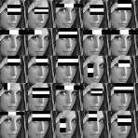 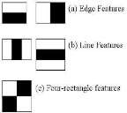

Figure 2.2: Haar Feature

Viola-Jones algorithm analyses a given image using Haar features consisting of multiple rectangles (Mekha Joseph et al., 2016).

In the fig shows several types of Haar features. The features perform as window function mapping onto the image. A single value result, which representing each feature can be computed by subtracting the sum of the white rectangle(s) from the sum of the black rectangle(s).

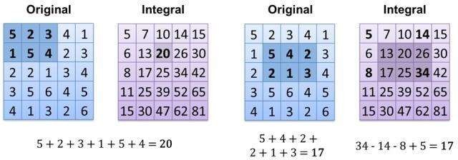

Figure 2.3: Integral of Image

The value of integrating image in a specific location is the sum of pixels on the left and the top of the respective location. In order to illustrate clearly, the value of the integral image at location 1 is the sum of the pixels in rectangle A. The values

of integral image at the rest of the locations are cumulative. For instance, the value at location 2 is summation of A and B, (A + B), at location 3 is summation of A and C, (A + C), and at location 4 is summation of all the regions, (A + B + C + D). Therefore, the sum within the D region can be computed with only addition and subtraction of diagonal at location 4 + 1 − (2 + 3) to eliminate rectangles A, B and C.

* + 1. **Local Binary Pattern Histogram**

Local Binary Pattern (LBP) is a simple yet very efficient texture operator which labels the pixels of an image by thresholding the neighborhood of each pixel and considers the result as a binary number.

It was first described in 1994 (LBP) and has since been found to be a powerful feature for texture classification. It has further been determined that when LBP is combined with histograms of oriented gradients (HOG) descriptor, it improves the detection performance considerably on some datasets. Using the LBP combined with histograms we can represent the face images with a simple data vector.

**LBPH algorithm work step by step:**

LBPH algorithm work in 5 steps.

* + - 1. **Parameters:** the LBPH uses 4 parameters:
         * **Radius:** the radius is used to build the circular local binary pattern and represents the radius around the central pixel. It is usually set to 1.
         * **Neighbors:** the number of sample points to build the circular local binary pattern. Keep in mind: the more sample points you include, the higher the computational cost. It is usually set to 8.
         * **Grid X:** the number of cells in the horizontal direction. The more cells, the finer the grid, the higher the dimensionality of the resulting feature vector. It is usually set to 8.
         * **Grid Y:** the number of cells in the vertical direction. The more cells, the finer the grid, the higher the dimensionality of the resulting feature vector. It is usually set to 8.
      2. **Training the Algorithm:** First, we need to train the algorithm. To do so, we need to use a dataset with the facial images of the people we want to recognize. We need to also set an ID (it may be a number or the name of the person) for each image, so the algorithm will use this information to recognize an input image and give you an output. Images of the same person must have the same ID. With the training set already constructed, let’s see the LBPH computational steps.
      3. **Applying the LBP operation:** The first computational step of the LBPH is to create an intermediate image that describes the original image in a better way, by highlighting the facial characteristics. To do so, the algorithm uses a concept of a sliding window, based on the parameters radius and neighbors.

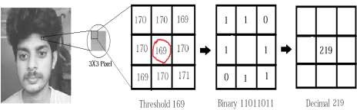The image below shows this procedure:

Figure 2.4: LBP Operation

Based on the image above, let’s break it into several small steps so we can understand it easily:

* Suppose we have a facial image in grayscale.
* We can get part of this image as a window of 3x3 pixels.
* It can also be represented as a 3x3 matrix containing the intensity of each pixel (0~255).
* Then, we need to take the central value of the matrix to be used as the threshold.
* This value will be used to define the new values from the 8 neighbors.
* For each neighbor of the central value (threshold), we set a new binary value. We set 1 for values equal or higher than the threshold and 0 for values lower than the threshold.
* Now, the matrix will contain only binary values (ignoring the central value). We need to concatenate each binary value from each position from the matrix line by line into a new binary value (e.g. 10001101). Note: some authors use other approaches to concatenate the binary values (e.g. clockwise direction), but the final result will be the same.
* Then, we convert this binary value to a decimal value and set it to the central value of the matrix, which is actually a pixel from the original image.
* 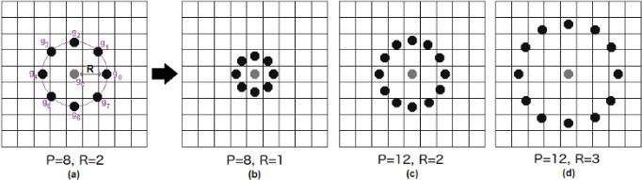At the end of this procedure (LBP procedure), we have a new image which represents better the characteristics of the original image.

Figure 2.5: The LBP operation Radius Change

It can be done by using bilinear interpolation. If some data point is between the pixels, it uses the values from the 4 nearest pixels (2x2) to estimate the

value of the new data point.

* + - 1. **Extracting the Histograms:** Now, using the image generated in the last step, we can use the Grid X and Grid Y parameters to divide the image into multiple grids, as can be seen in the following image:

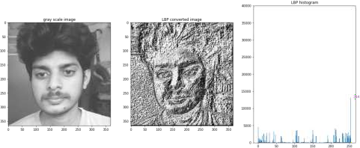

Figure 2.6: Extracting The Histogram

Based on the image above, we can extract the histogram of each region as follows:

* + - * + As we have an image in grayscale, each histogram (from each grid) will contain only 256 positions (0~255) representing the occurrences of each pixel intensity.
        + Then, we need to concatenate each histogram to create a new and bigger histogram. Supposing we have 8x8 grids, we will have 8x8x256=16.384 positions in the final histogram. The final histogram represents the characteristics of the image original image.
      1. **Performing the face recognition:** In this step, the algorithm is already trained. Each histogram created is used to represent each image from the training dataset. So, given an input image, we perform the steps again for this new image and creates a histogram which represents the image.
         * So to find the image that matches the input image we just need to compare two histograms and return the image with the closest histogram.
         * We can use various approaches to compare the histograms (calculate the distance between two histograms), for example: Euclidean distance, chi-square, absolute value, etc. In this example, we can use the **Euclidean distance** (which is quite known) based on the following formula:

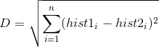

* + - * + So the algorithm output is the ID from the image with the closest histogram. The algorithm should also return the calculated distance, which can be used as a ‘confidence’ measurement.
        + We can then use a threshold and the ‘confidence’ to automatically estimate if the algorithm has correctly recognized the image. We can assume that the algorithm has successfully recognized if the confidence is lower than the threshold defined.

**CHAPTER-3 MODAL IMPLEMENTATION**

**AND ANALYSIS**

* 1. **INTRODUCTION:**

Face detection involves separating image windows into two classes; one containing faces (turning the background (clutter). It is difficult because although commonalities exist between faces, they can vary considerably in terms of age, skin color and facial expression. The problem is further complicated by differing lighting conditions, image qualities and geometries, as well as the possibility of partial occlusion and disguise. An ideal face detector would therefore be able to detect the presence of any face under any set of lighting conditions, upon any background. The face detection task can be broken down into two steps. The first step is a classification task that takes some arbitrary image as input and outputs a binary value of yes or no, indicating whether there are any faces present in the image. The second step is the face localization task that aims to take an image as input and output the location of any face or faces within that image as some bounding box with (x, y, width, height).After taking the picture the system will compare the equality of the pictures in its database and give the most related result.

* 1. **Modal Implementation:**

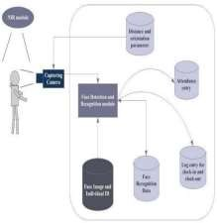

Figure 3.1: Model Implement

The main components used in the implementation approach are open source computer vision library (OpenCV). One of OpenCV’s goals is to provide a simple- to-use computer vision infrastructure that helps people build fairly sophisticated vision applications quickly. OpenCV library contains over 500 functions that span many areas in vision. The primary technology behind Face recognition is OpenCV. The user stands in front of the camera keeping a minimum distance of 50cm and his image is taken as an input. The frontal face is extracted from the image then converted to gray scale and stored. The Principal component Analysis (PCA) algorithm is performed on the images and the eigen values are stored in an xml file. When a user requests for recognition the frontal face is extracted from the captured video frame through the camera. The eigen value is re-calculated for the test face and it is matched with the stored data for the closest neighbour.

* 1. **Design Requirements:**

We used some tools to build the system. Without the help of these tools it would not be possible to make it done. Here we will discuss about the most important one.

* + 1. **Software Implementation:**
       1. **OpenCV:** We used OpenCV 3 dependency for python 3. OpenCV is library where there are lots of image processing functions are available. This is very useful library for image processing. Even one can get expected outcome without writing a single code. The library is cross-platform and free for use under the open-source BSD license. Example of some supported functions are given bellow:
          - **Derivation**: Gradient/Laplacian computing, contours delimitation
          - **Hough transforms:** lines, segments, circles, and geometrical shapes detection
          - **Histograms**: computing, equalization, and object localization with back projection algorithm
          - **Segmentation**: thresholding, distance transform, foreground/background detection, watershed segmentation
          - **Filtering**: linear and nonlinear filters, morphological operations
          - **Cascade detectors**: detection of face, eye, car plates
          - **Interest points**: detection and matching
          - **Video processing:** optical flow, background subtraction, camshaft (object tracking)
          - **Photography**: panoramas realization, high definition imaging (HDR), image inpainting

So it was very important to install OpenCV. But installing OpenCV 3 is a complex process. How we did it is given below:

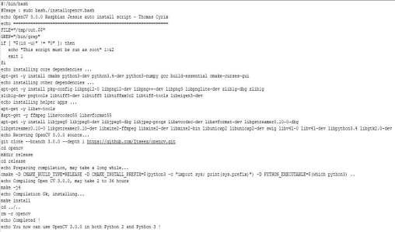

Fig 3.2: Installing OpenCV

We copied this script and place it on a directory on our raspberry pi and saved it. Then through terminal we made this script executable and then ran it.

Sudo chmod 755 /myfile/pi/installopencv.bash sudo /myfile/pi/installopencv.bash

these are the command line we used.

* + - 1. **Python IDE:** There are lots of IDEs for python. Some of them are PyCharm, Thonny, Ninja, Spyder, VS code. Ninja and Spyder both are very excellent and free but we used VS code for implementation. We installed Spyder through the command line below.
* sudo apt install code
  1. **Experimental Results:**

The step of the experiments process are given below:

**Face Detection:**

Start capturing images through CCTV camera of the client side:

* Pre-process the captured image and extract face image
* calculate the eigen value of the captured face image and compared with eigen values of existing faces in the database.
* If eigen value does not matched with existing ones,save the new face image information to the face database (xml file).
* If eigen value matched with existing one then recognition step will done.

**Face Recognition:**

Using PCA algorithm the following steps would be followed in for face recognition:

* Find the face information of matched face image in from the database.
* update the log table with corresponding face image and system time that makes completion of attendance for an individua students.

This section presents the results of the experiment conducted to capture the face into a grey scale image of 50x50 pixels.

|  |  |  |  |
| --- | --- | --- | --- |
| Test data | Expected Result | Observed  Result | Pass/  Fail |
| OpenCAM_CB() | Connects with the installed camera and  starts playing. | Camera started. | pass |
| LoadHaar Classifier() | Loads the  HaarClassifier Cascade files for frontal face | Gets ready for Extraction. | Pass |
| ExtractFace() | Initiates the Paul-  Viola  Face extracting Frame  work. | Face extracted | Pass |
| Learn() | Start the PCA  Algorithm | Updates the  facedata. xml | Pass |
| Recognize() | It compares the input face with the saved faces. | Nearest face | Pass |

Table 3.2 Experimental Results-1

Here is our data set sample.

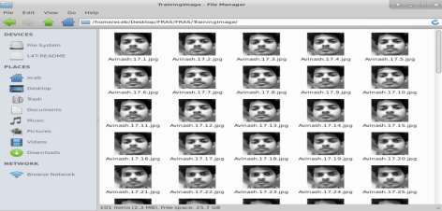

Figure 3.13 : Dataset sample

|  |  |  |
| --- | --- | --- |
| **Face Orientations** | **Detection Rate** | **Recognition Rate** |
| 0o (Frontal face) | 98.7 % | 95% |
| 18º | 80.0 % | 78% |
| 54º | 59.2 % | 58% |
| 72º | 0.00 % | 0.00% |
| 90º(Profile face) | 0.00 % | 0.00% |

Table 3.3 Experimentaal Results-2

We performed a set of experiments to demonstrate the efficiency of the proposed method. 30 different images of 10 persons are used in training set. Figure 3 shows a sample binary image detected by the ExtractFace() function using Paul-Viola Face extracting Frame work detection method.

Activity diagram

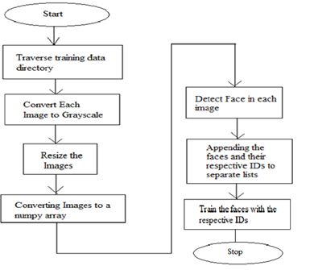

Sequence diagram

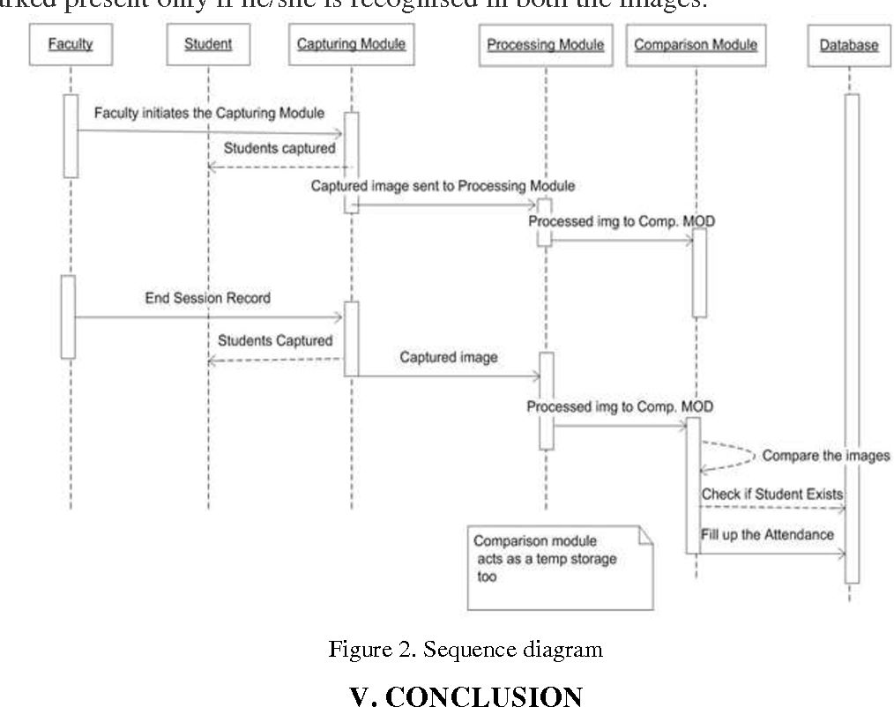

**CHAPTER-4**

**CODE IMPLEMENTATION**

* 1. **Code Implementation:**

All our code is written in Python language. First here is our project directory structure and files.

Project

[Attendance]

[StudentDetails]

[TrainingImage]

[Traininglabel]

attendance.py

automatic attendance.py

takeImage.py

trainimage.py

haarcascade_frontalface_default.xml

showattendance.py

All those file in the project directory.

Note: The names inside square brackets [“folder name”] indicate it is a folder. [Attendance] => It contains all the attendance sheets saved after taking attendance.

[image label] => Unknown images are placed inside this folder to avoid false positives. [StudentDetails] => Here we place Studentdetails.csv file to use while recognizing faces. [Trainingimage] => After capture dataset of a student, all his/her images are stored here.

* + 1. **attendance.py**

All the work will be done here, Detect the face ,recognize the faces and take attendance.

import os

import pyttsx3

Root_Path = os.path.dirname(_file_)

haarcasecade_path = os.path.join(Root_Path,"haarcascade_frontalface_default.xml")

trainimagelabel_path = os.path.join(Root_Path,"TrainingImageLabel\\Trainner.yml")

trainimage_path = os.path.join(Root_Path,"TrainingImage")

studentdetail_path = os.path.join(Root_Path,"StudentDetails\\studentdetails.csv")

attendance_path = os.path.join(Root_Path,"Attendance")

# project module

import show_attendance

import takeImage

import automaticAttendance

import trainImage

def text_to_speech(user_text):

engine = pyttsx3.init()

engine.say(user_text)

engine.runAndWait()

def main():

while True:

print("1. Register")

print("2. Take Attendance")

print("3. View Attendance")

choice = input(("Enter your choice: "))

if choice == '1':

EnrollmentNo = int(input("Enter Enrollment Number: "))

Name = input("Enter Student name: ")

res = takeImage.TakeImage(

EnrollmentNo,

Name,

haarcasecade_path,

trainimage_path,

text_to_speech

)

if res == 'Success':

train = input("Type 'y' if you want to start the training to complete registration: ")

if train.lower() == 'y':

trainImage.TrainImage(haarcasecade_path, trainimage_path, trainimagelabel_path,text_to_speech)

elif choice == '2':

automaticAttendance.subjectChoose(text_to_speech)

elif choice == '3':

show_attendance.subjectChoose()

else:

print("Invalid Choice")

print()

# main()

if _name_ == '_main_':

main()

* + 1. **automaticattendance.py**

import tkinter as tk

from tkinter import *

import os, cv2

import shutil

import csv

import numpy as np

import pandas as pd

import datetime

import time

from attendance import haarcasecade_path, trainimagelabel_path, studentdetail_path, attendance_path

def subjectChoose(text_to_speech):

subject = input("Enter Subject: ")

now = time.time()

future = now + 20

recognizer = cv2.face.LBPHFaceRecognizer_create()

try:

recognizer.read(trainimagelabel_path)

except:

err = "Model not found, please train model"

text_to_speech(err)

else:

facecasCade = cv2.CascadeClassifier(haarcasecade_path)

df = pd.read_csv(studentdetail_path)

cam = cv2.VideoCapture(0)

font = cv2.FONT_HERSHEY_SIMPLEX

col_names = ["Enrollment", "Name"]

attendance = pd.DataFrame(columns=col_names)

while True:

___, im = cam.read()

gray = cv2.cvtColor(im, cv2.COLOR_BGR2GRAY)

faces = facecasCade.detectMultiScale(gray, 1.2, 5)

for (x, y, w, h) in faces:

global Id

Id, conf = recognizer.predict(gray[y : y + h, x : x + w])

if conf < 70:

print(conf)

print(Id)

ts = time.time()

date = datetime.datetime.fromtimestamp(ts).strftime(

"%Y-%m-%d"

)

timeStamp = datetime.datetime.fromtimestamp(ts).strftime(

"%H:%M:%S"

)

aa = df.loc[df["Enrollment"] == Id]["Name"].values

global tt

tt = str(Id) + "-" + aa

# En='1604501160'+str(Id)

attendance.loc[len(attendance)] = [

Id,

aa,

]

cv2.rectangle(im, (x, y), (x + w, y + h), (0, 260, 0), 4)

cv2.putText(

im, str(tt), (x + h, y), font, 1, (255, 255, 0,), 4

)

else:

Id = "Unknown"

tt = str(Id)

cv2.rectangle(im, (x, y), (x + w, y + h), (0, 25, 255), 7)

cv2.putText(

im, str(tt), (x + h, y), font, 1, (0, 25, 255), 4

)

if time.time() > future:

break

attendance = attendance.drop_duplicates(

["Enrollment"], keep="first"

)

cv2.imshow("Filling Attendance...", im)

key = cv2.waitKey(30) & 0xFF

if key == 27:

break

ts = time.time()

print(aa)

# attendance["date"] = date

# attendance["Attendance"] = "P"

attendance[date] = 1

date = datetime.datetime.fromtimestamp(ts).strftime("%Y-%m-%d")

timeStamp = datetime.datetime.fromtimestamp(ts).strftime("%H:%M:%S")

Hour, Minute, Second = timeStamp.split(":")

# fileName = "Attendance/" + Subject + ".csv"

path = os.path.join(attendance_path, subject)

fileName = (

f"{path}/"

+ subject

+ "_"

+ date

+ "_"

+ Hour

+ "-"

+ Minute

+ "-"

+ Second

+ ".csv"

)

attendance = attendance.drop_duplicates(["Enrollment"], keep="first")

print(attendance)

attendance.to_csv(fileName, index=False)

m = "Attendance Filled Successfully of " + subject

print(m)

text_to_speech(m)

cam.release()

cv2.destroyAllWindows()

* + 1. **takeimage.py**

import csv

import os, cv2

from attendance import studentdetail_path

# take Image of user

def TakeImage(l1, l2, haarcasecade_path, trainimage_path,text_to_speech):

if (l1 == "") and (l2==""):

t='Please Enter the your Enrollment Number and Name.'

text_to_speech(t)

elif l1=='':

t='Please Enter the your Enrollment Number.'

text_to_speech(t)

elif l2 == "":

t='Please Enter the your Name.'

text_to_speech(t)

else:

try:

cam = cv2.VideoCapture(0)

detector = cv2.CascadeClassifier(haarcasecade_path)

Enrollment = str(l1)

Name = l2

sampleNum = 0

directory = Enrollment + "_" + Name

path = os.path.join(trainimage_path, directory)

os.mkdir(path)

while True:

ret, img = cam.read()

gray = cv2.cvtColor(img, cv2.COLOR_BGR2GRAY)

faces = detector.detectMultiScale(gray, 1.3, 5)

for (x, y, w, h) in faces:

cv2.rectangle(img, (x, y), (x + w, y + h), (255, 0, 0), 2)

sampleNum = sampleNum + 1

cv2.imwrite(

f"{path}\ "

+ Name

+ "_"

+ Enrollment

+ "_"

+ str(sampleNum)

+ ".jpg",

gray[y : y + h, x : x + w],

)

cv2.imshow("Frame", img)

if cv2.waitKey(1) & 0xFF == ord("q"):

break

elif sampleNum > 50:

break

cam.release()

cv2.destroyAllWindows()

row = [Enrollment, Name]

with open(

studentdetail_path,

"a+",newline='\n'

) as csvFile:

writer = csv.writer(csvFile, delimiter=",")

writer.writerow(row)

csvFile.close()

res = "Images Saved for ER No:" + Enrollment + " Name:" + Name

print(res)

text_to_speech(res)

return "Success"

except FileExistsError as F:

F = "Student Data already exists"

text_to_speech(F)

return "Failed"

* + 1. **trainimage.py**

This checkcamra.py will check weather the camera is correctly connected or not, if connected whether the face is detecting or not.

import os, cv2

import numpy as np

from PIL import ImageTk, Image

# Train Image

def TrainImage(haarcasecade_path, trainimage_path, trainimagelabel_path,text_to_speech):

recognizer = cv2.face.LBPHFaceRecognizer_create()

# detector = cv2.CascadeClassifier(haarcasecade_path)

faces, Id = getImagesAndLables(trainimage_path)

recognizer.train(faces, np.array(Id))

recognizer.save(trainimagelabel_path)

res = "Image Trained successfully" # +",".join(str(f) for f in Id)

print(res)

text_to_speech(res)

def getImagesAndLables(path):

# imagePath = [os.path.join(path, f) for d in os.listdir(path) for f in d]

# newdir = [os.path.join(path, d) for d in os.listdir(path)]

# imagePath = [

# os.path.join(newdir[i], f)

# for i in range(len(newdir))

# for f in os.listdir(newdir[i])

# ]

imagePath = []

for root,dirs,files in os.walk(path):

for File in files:

imagePath.append(os.path.join(root,File))

faces = []

Ids = []

for imagePath in imagePath:

pilImage = Image.open(imagePath).convert("L")

imageNp = np.array(pilImage, "uint8")

Id = int(os.path.split(imagePath)[-1].split("_")[1])

faces.append(imageNp)

Ids.append(Id)

return faces, Ids

* + 1. **showattendance.py**

import os

from attendance import attendance_path

def subjectChoose():

subject = input("Enter subject: ")

os.startfile(os.path.join(attendance_path,subject))

**4.1.6 requirement.txt**

This file consists all the required files to be install before executing the codes.

pip install os-sys

pip install pyttsx3

pip install tkintertable

pip install opencv-python

pip install numpy

pip install pandas

pip install os-sys

pip install python-csv

pip install pyttsx3

**4.2 Sample Images:**

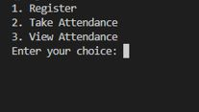

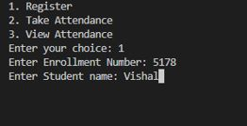

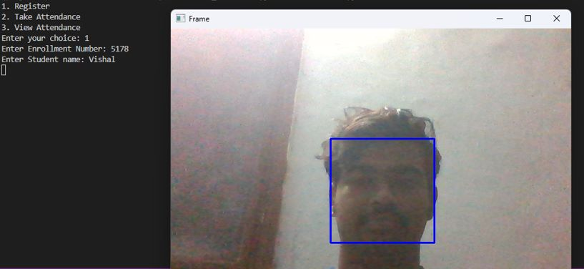

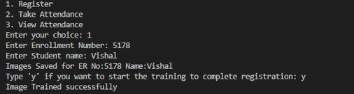

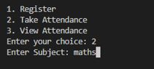

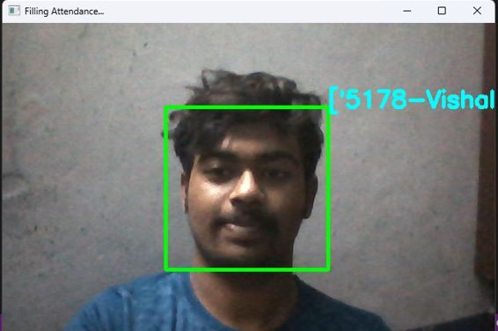

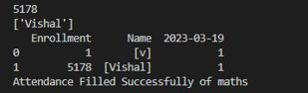





Figure 4.1 :Output Images

**CHAPTER-5 WORK PLAN**

* 1. **Introduction:**

A project work plan allows you to outline the requirements of a project, project

planning steps, goals, and team members involved in the project.Within each goal, you're going to outline the necessary Key Action Steps in project planning, the requirements, and who's involved in each action step.

**Key Action Step:**

* + - Expected Outcome -Add this as a task. The Expected outcome will be the part of Project
    - Assignees – Assigning the work to the team members.
    - Completion Date -Add a due date and tries to finish the work within the time
  1. **Work Breakdown Structure:**

In order to develop this system, we gave enormous importance to scheduling because we believed if we want to provide the best of quality in a given period of time then we must give due importance to scheduling which also helped us to achieve a better results.we observe the entire work structure, meaning how the scheduling was maintained throughout the developmental phase. We shall also see the financial foundation of this project and furthermore the feasibility study should be also discussed.

|  |  |  |
| --- | --- | --- |
| **Month** | **Activity** | **status** |
| December | Selection of project area and Study of the related work. | Completed |
| December | Literature Survey and Study of Journals related to the work | Completed |
| December-  January | Study on the software implementation works python and image processing | Completed |

|  |  |  |
| --- | --- | --- |
| January | Study of project related works like face recognition and detection techniques | Completed |
| January | Study of the Image processing in python and Open Computer Vision | Completed |
| February | Study of hardware and selection of components | Completed |
| February | Study of hardware implementation and installation OS | Completed |
| February | Study related to creating the environments and working platform | Completed |
| March | Study of packages/tools and installation of packages | Completed |
| March | Implementation of algorithm in Software. | Completed |
| March | Implementation of code in hardware | Completed |

Table 5.1 Work Plan

**4.2.1 Financial Plan**

Financial Plan identifies the Project Finance needed to meet specific objectives. The Financial Plan defines all of the various types of expenses that a project will incur (equipment, materials and administration costs) along with an estimation of the value of each expense. The Financial Plan also summarizes the total expense to be incurred across the project and this total expense becomes the project budget. As part of the Financial Planning exercise, a schedule is provided which states the amount of money needed during each stage of the project.

|  |  |
| --- | --- |
| **Components** | **price** |
| High Definition Camera | 3500 |
| Sd Card | 800 |
| Hardware Accessories | 500 |
| Total | 4800 |

Table 5.2 Financial Plan

**CHAPTER-6 PERFORMANCE ANALYSIS**

* 1. **Introduction:**

We conducted a series of experiments to illustrate the system performance under different situations. By carrying out those tests, we were able to get the graph shown above (Distance vs Confidence Level). We may deduce from the graph that when the face is closer to the camera, the confidence level is higher, and vice versa. Therefore, by keeping a threshold for confidence level, we can mark attendance to the person according to the threshold.

* 1. **Analysis:**

Here we consider one constant parameter intensity of light . we performed different experiments on different distance and different angles. we observed the confidence level

at the different positions by gradually increasing the distance .we plotted the graph using the x and y coordinates by considering the x values as the confidence level or accuracy rate. and y values as the distance (cms).

* 1. **Flow Chart:**

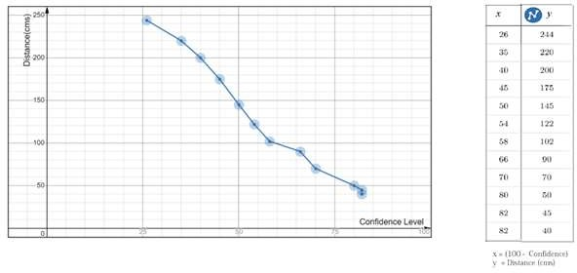

Figure 6.1 Flow Chart

**CONCLUSION**

Face recognition systems are part of facial image processing applications and their significance as a research area are increasing recently. Implementations of system are crime prevention, video surveillance, person verification, and similar security activities. The face recognition system implementation can be part of Universities. Face Recognition Based Attendance System has been envisioned for the purpose of reducing the errors that occur in the traditional (manual) attendance taking system. The aim is to automate and make a system that is useful to the organization such as an institute. The efficient and accurate method of attendance in the office environment that can replace the old manual methods. This method is secure enough, reliable and available for use. Proposed algorithm is capable of detect multiple faces, and performance of system has acceptable good results.

**REFERENCES**

1. A brief history of Facial Recognition, NEC, New Zealand,26 May 2020.[Online]. Available: https://[www.nec.co.nz/market-leadership/publications-media/a-brief-history-of-facial-](http://www.nec.co.nz/market-leadership/publications-media/a-brief-history-of-facial-) recognition/
2. Face detection,TechTarget Network, Corinne Bernstein, Feb, 2020.[Online]. Available: <https://searchenterpriseai.techtarget.com/definition/face-detection>
3. Paul Viola and Michael Jones, Rapid Object Detection using a Boosted Cascade of Simple Features. Accepted Conference on Computer Vision and Pattern Re cognition, 2001.
4. Face Detection with Haar Cascade,Towards Data Science-727f68dafd08,Girija Shankar Behera, India, Dec 24, 2020.[Online]. Available:https://towardsdatascience.com/face-detection- with-haar-cascade-727f68dafd08
5. Face Recognition: Understanding LBPH Algorithm,Towards Data Science- 90ec258c3d6b,Kelvin Salton do Prado, Nov 11, 2017.[Online]. Available

:https://towardsdatascience.com/face-recognition-how-lbph-works-90ec258c3d6b

1. What is Facial Recognition and how sinister is it, Theguardian, IanSample, July, 2019. [Online]. Available: https://[www.theguardian.com/technology/2019/jul/29/what-is-facial-](http://www.theguardian.com/technology/2019/jul/29/what-is-facial-) recognition-and-how-sinister-is-it
2. Kushsairy Kadir , Mohd Khairi Kamaruddin, Haidawati Nasir, Sairul I Safie, Zulkifli Abdul Kadir Bakti,"A comparative study between LBP and Haar-like features for Face Detection using OpenCV", 4th International Conference on Engineering Technology and Technopreneuship (ICE2T), DOI:10.1109/ICE2T.2014.7006273, 12 January 2015.
3. Senthamizh Selvi.R,D.Sivakumar, Sandhya.J.S , Siva Sowmiya.S, Ramya.S , Kanaga Suba Raja.S,"Face Recognition Using Haar - Cascade Classifier for Criminal Identification", International Journal of Recent Technology and Engineering(IJRTE), vol.7, issn:2277-3878, , issue-6S5, April 2019
4. Margaret Rouse, What is facial recognition? - Definition from WhatIs.com, 2012. [online]

Available at: <http://whatis.techtarget.com/definition/facial-recognition>

1. Robert Silk, Biometrics: Facial recognition tech coming to an airport near you: Travel Weekly, 2017. [online] Available at:https://[www.travelweekly.com/Travel-News/Airline-](http://www.travelweekly.com/Travel-News/Airline-)

News/Biometrics-Facial-recognition-tech-coming-airport-near-you

1. Sidney Fussell, NEWS Facebook's New Face Recognition Features: What We Do (and Don't) Know, 2018. [online] Available at: [https://gizmodo.com/facebooks-new-face-recognition-fea](https://gizmodo.com/facebooks-new-face-recognition-fea%20tures-what-we-do-an-1823359911) [tures-what-we-do-an-1823359911](https://gizmodo.com/facebooks-new-face-recognition-fea%20tures-what-we-do-an-1823359911)
2. Reichert, C. Intel demos 5G facial-recognition payment technology | ZDNet, 2017. [online] ZDNet. Available at: https://[www.zdnet.com/article/intel-demos-5g-facial-recognition-payment-](http://www.zdnet.com/article/intel-demos-5g-facial-recognition-payment-) technology/#:~:text=Such%20%22pay%20via%20face%20identification,and%20artificial%20int elligence%20(AI). [Accessed 25 Mar. 2018].
3. [Mayank Kumar Rusia,](https://ieeexplore.ieee.org/author/37087500828) [Dushyant Kumar Singh,](https://ieeexplore.ieee.org/author/37087499158) [Mohd. Aquib Ansari,](https://ieeexplore.ieee.org/author/37087500732) “Human Face Identification using LBP and Haar-like Features for Real Time Attendance Monitoring”, [2019](https://ieeexplore.ieee.org/xpl/conhome/8966550/proceeding) [Fifth International Conference on Image Information Processing (ICIIP)](https://ieeexplore.ieee.org/xpl/conhome/8966550/proceeding) ,Shimla, India, DOI: [10.1109/ICIIP47207.2019.8985867](https://doi.org/10.1109/ICIIP47207.2019.8985867) 10 February 2020.